

**ExamEase : University Semester Exam Registration Portal**

**Using Flask on AWS EC2 and RDS**

**By:**

**Parimi Naveen Kumar**

[**218x1a4239@khitguntur.ac.in**](mailto:218x1a4239@khitguntur.ac.in)

**Makkena Saraswathi**

[**218x1a4263@khitguntur.ac.in**](mailto:218x1a4263@khitguntur.ac.in)

**Kolamuri Gnana Teja**

[**218x1a4260@khitguntur.ac.in**](mailto:218x1a4260@khitguntur.ac.in)

**R.L.S.Abhiram**

[**218x1a4231@khitguntur.ac.in**](mailto:218x1a4231@khitguntur.ac.in)

**ExamEase: University Semester Exam Registration Portal**

### **Project Description:**

**ExamEase: University Semester Exam Registration Portal** is a streamlined application designed 9to simplify the semester exam registration process for university students. Built with Flask for backend functionality, hosted on AWS EC2, and integrated with Amazon RDS for reliable data management, ExamEase provides a comprehensive portal where students can efficiently register for exams, select exam sessions, and track application status. The platform offers a user-friendly interface with intuitive navigation through key pages like registration, exam selection, payment, and confirmation. ExamEase ensures data security and scalability, allowing universities to manage peak registration periods effectively. By digitizing exam registration, ExamEase helps universities reduce administrative burdens and empowers students with an accessible and efficient registration process.

**Scenario 1: Scalable Infrastructure for Exam Form Submission**During peak registration periods, ExamEase relies on AWS EC2 to provide a scalable infrastructure that adapts to the fluctuating load as students submit their semester exam forms.The platform handles tasks such as form submissions, document uploads, and real-time validation checks. When thousands of students access the portal simultaneously, EC2 instances automatically scale to maintain a smooth user experience, ensuring that students can complete their forms without experiencing delays. This elasticity makes ExamEase capable of supporting university-wide form submissions efficiently, even during the busiest registration days.

**Scenario 2: Reliable Data Management with Amazon RDS**ExamEase utilizes Amazon RDS with MySQL to manage student records, form data, and exam schedules securely. The managed database system ensures high availability and automated backups, enabling quick and reliable data access for both students and administrators. During peak submission periods, RDS can scale to handle increased data transactions, supporting activities like student form verifications, fee payments, and record updates. This reliable data management enables university administrators to generate real-time reports on submission statuses, track overdue forms, and analyze student trends for effective planning.

**Scenario 3: Role-Based Access Control with AWS IAM**To protect student data and control access to sensitive information, ExamEase uses AWS IAM to implement role-based access control. Different user groups, such as students, faculty, and administrators, are granted specific permissions based on their roles. This limits access to sensitive records, such as student personal information and exam schedules, ensuring that only authorized personnel can access or modify data. With IAM, ExamEase maintains a secure environment that upholds data integrity while allowing each user type access to the necessary functionalities. This approach ensures that ExamEase meets high-security standards and complies with university data protection policies.

**AWS ARCHITECTURE**

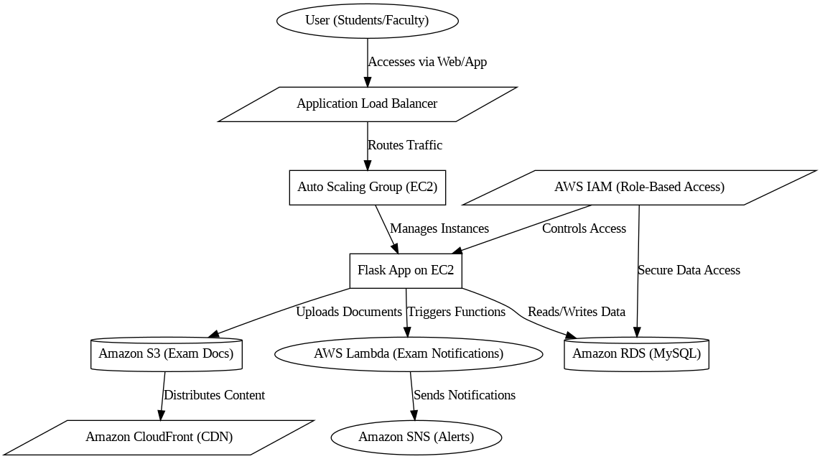

**ER Diagram: student_details, application,exam_fee and application_details:**

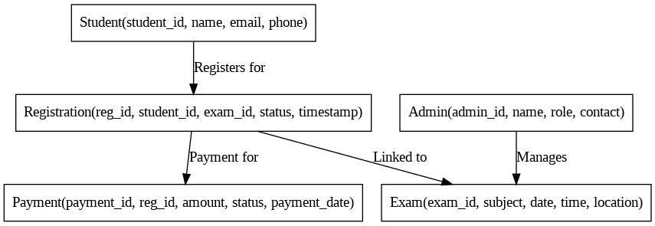

**Pre-requisites:**

### 1. AWS Account Setup: [https://youtu.be/CjKhQoYeR4Q?si=ui8Bvk_M4FfVM-D](https://youtu.be/CjKhQoYeR4Q?si=ui8Bvk_M4FfVM-Dh)h

### 2. Understanding of IAM: <https://youtu.be/gsgdAyGhV0o?si=3qg-bULgkD4LXNvR>

### 3. Knowledge of Amazon EC2 :<https://youtu.be/8TlukLu11Yo?si=MUj0nEAOESRhHUIz>

4. RDS : <https://www.youtube.com/live/MPau9c7PT74?si=A8OK-zFGbSKkAFWN>

5. MySQL WorkBench: <https://youtu.be/wALCw0F8e9M?si=ovMF9qMx5rLxaznB>

**Project WorkFlow:**

* **AWS Account Setup and Login**
  + **Activity 1.1:** Set up an AWS account if not already done.
  + **Activity 1.2:** Log in to the AWS Management Console to manage resources.
* **RDS Database Creation and Setup**
  + **Activity 2.1**: Create an RDS Instance.
  + **Activity 2.3**: Install MySQL Workbench.
* **Frontend Development and Application Setup**
  + **Activity 3.1**: Build the Frontend.
* **EC2 Instance Setup**
  + **Activity 4.1**: Launch EC2 Instance.
* **Deployment on EC2**
  + **Activity 5.1**: Deploy to EC2.
* **Testing and Deployment**
  + **Activity 6.1**: Functional Testing.
  + **Activity 6.2**: Deployment.

**Milestone 1: AWS Account Setup and Login**

* **Activity 1.1: Create AWS Account**
  + Sign up for an AWS account and configure billing settings.

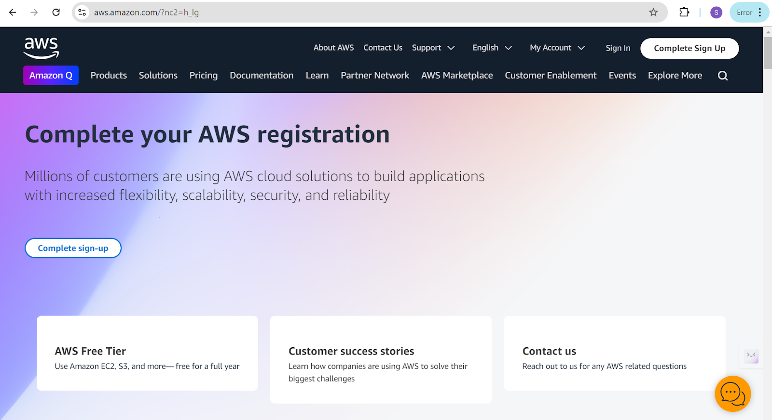

* **Activity 1.2: Login to AWS Management Console**
  + Access the AWS Management Console using your login credentials.

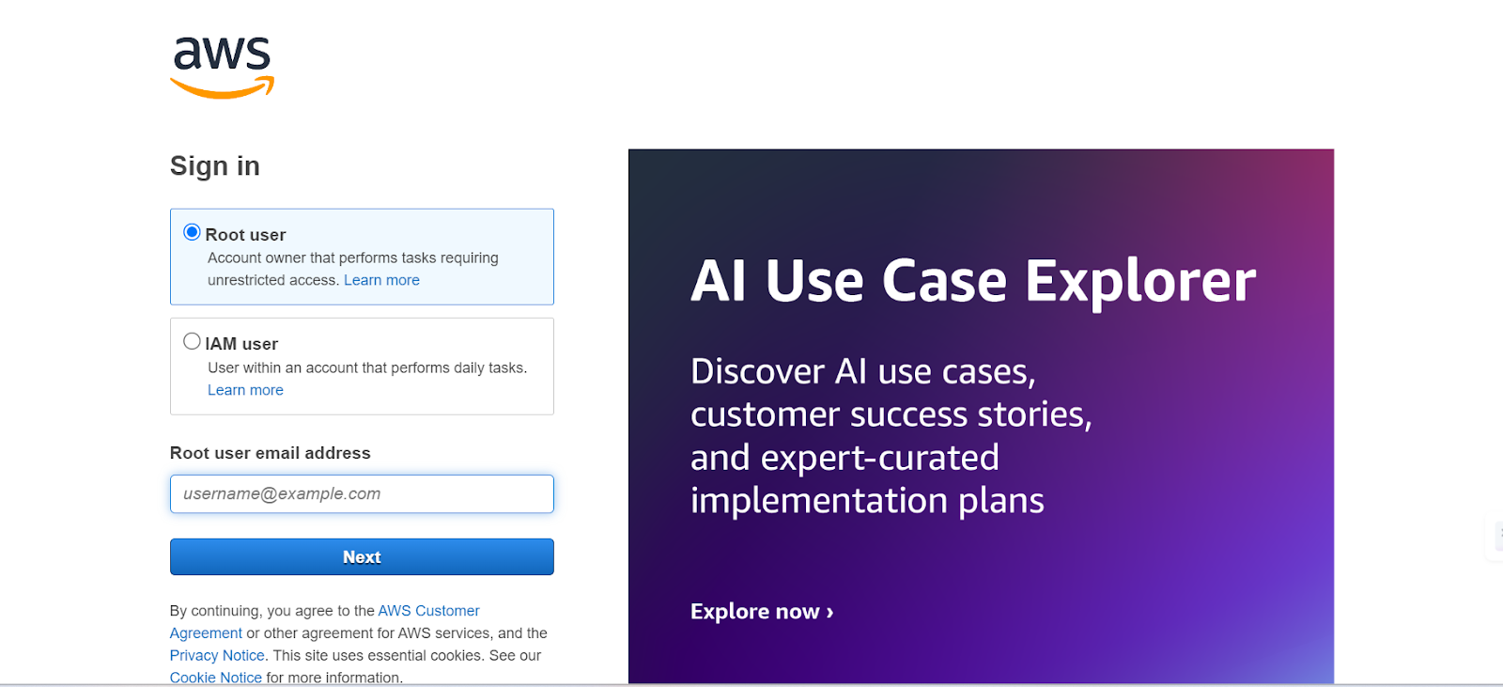

**Milestone 2: RDS Database Creation and Setup**

* **Activity 2.1: Create an RDS Instance**
  + Choose the RDS service from the AWS Management Console.

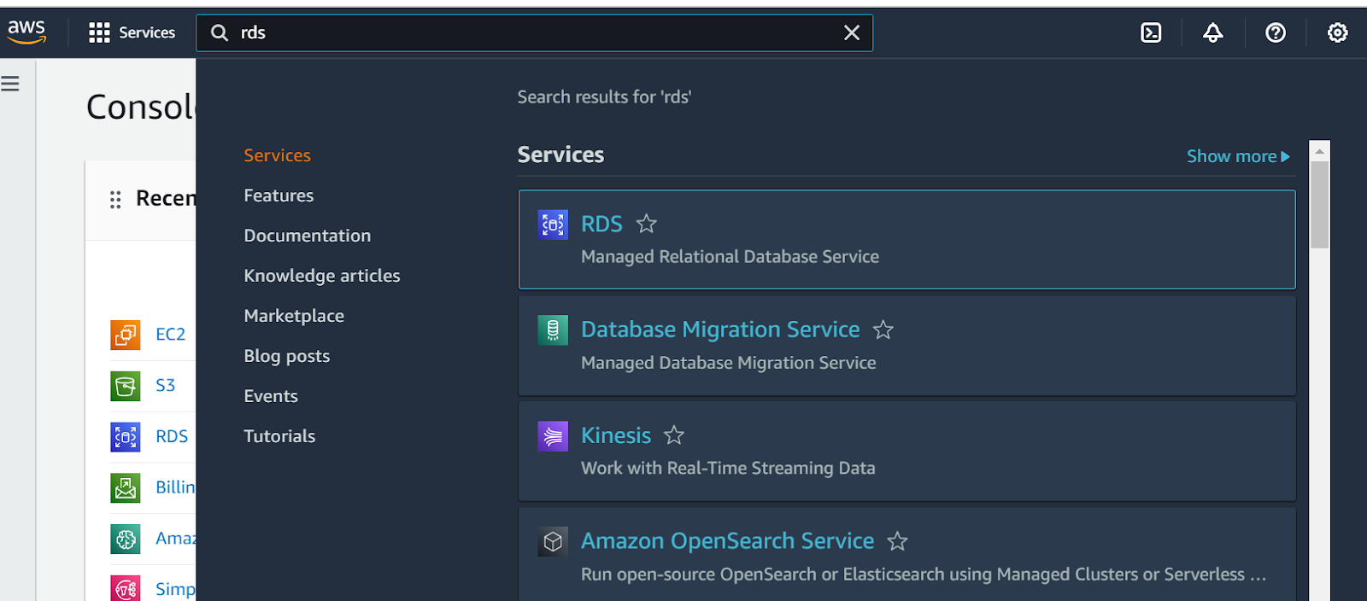

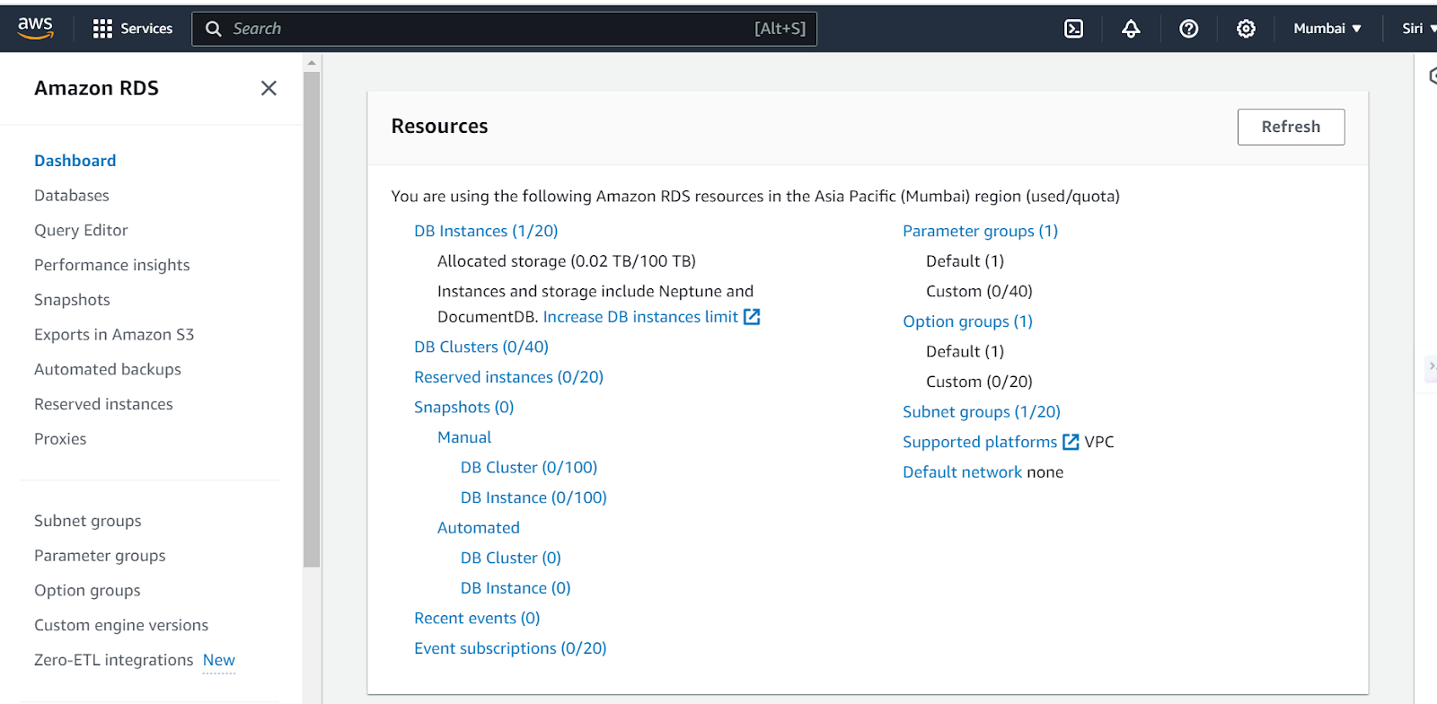

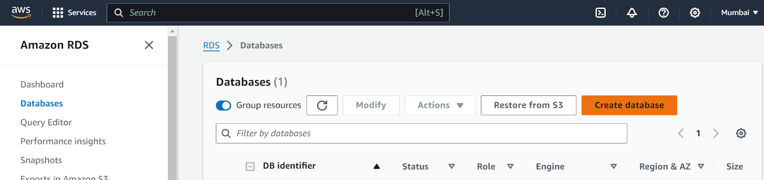

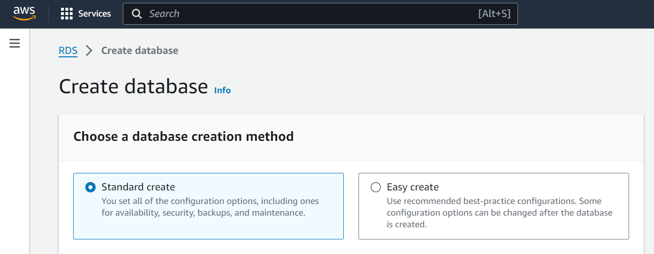

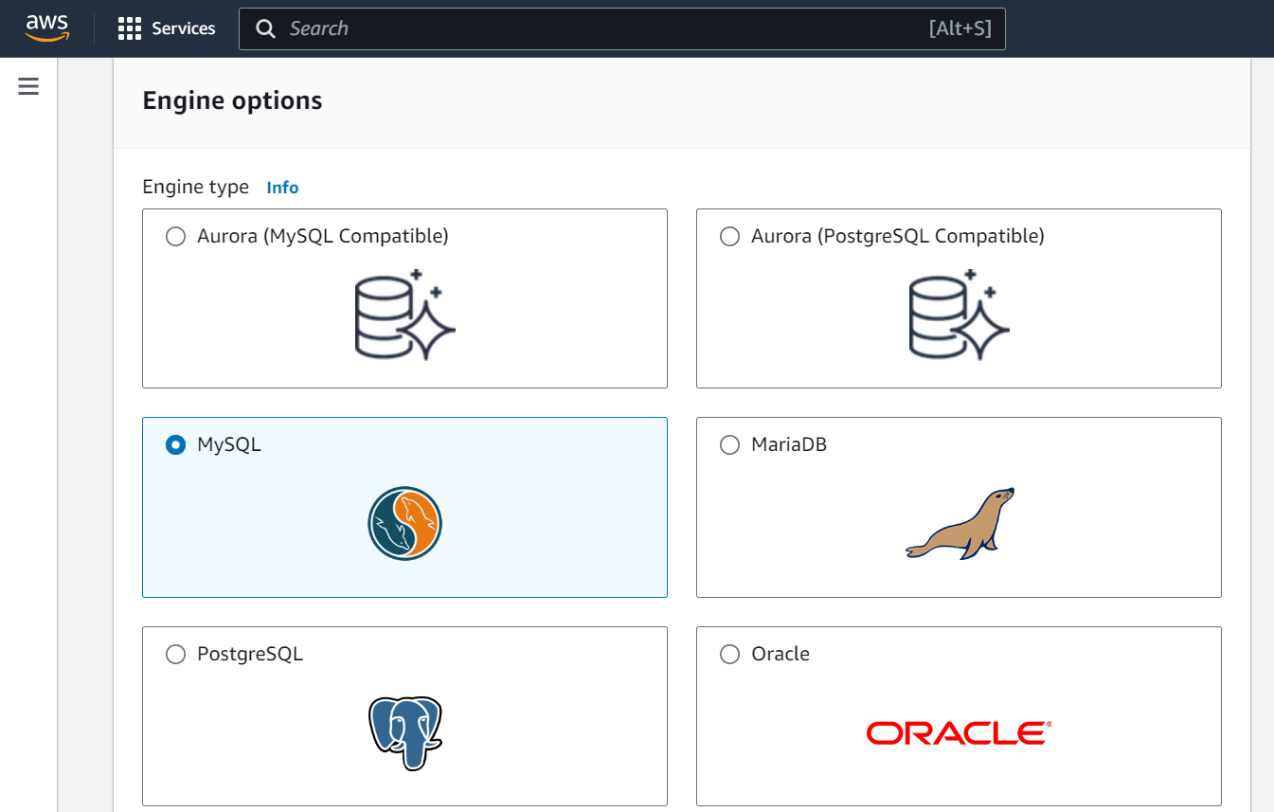

* + Select MySQL as the database engine, configure the instance settings (e.g., storage, instance class), and launch the RDS instance.

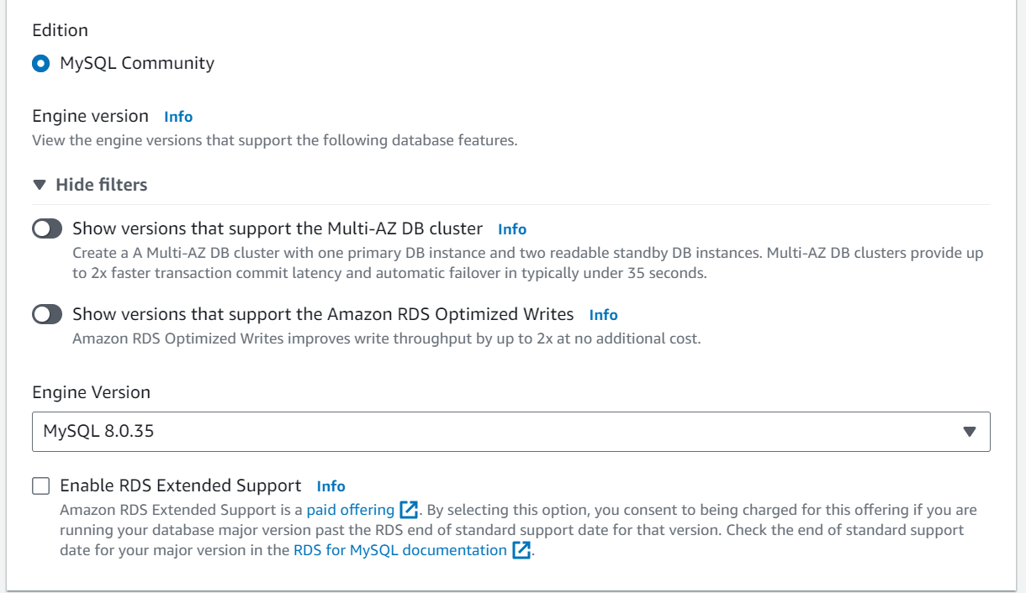

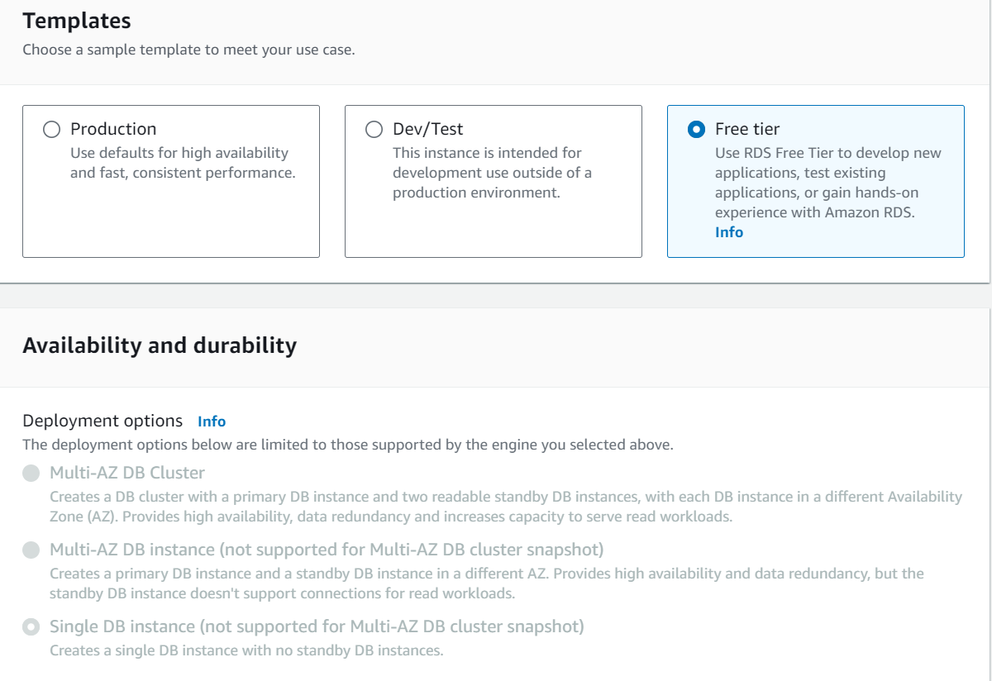

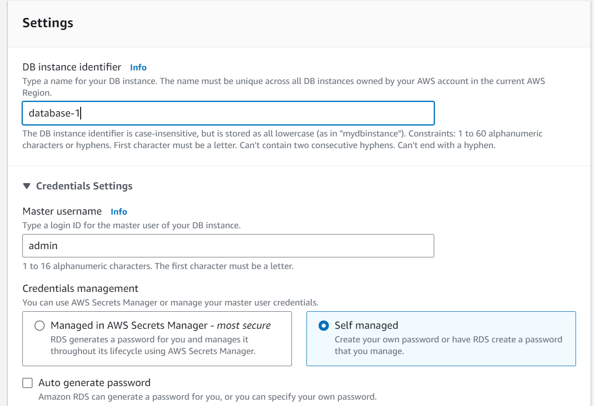

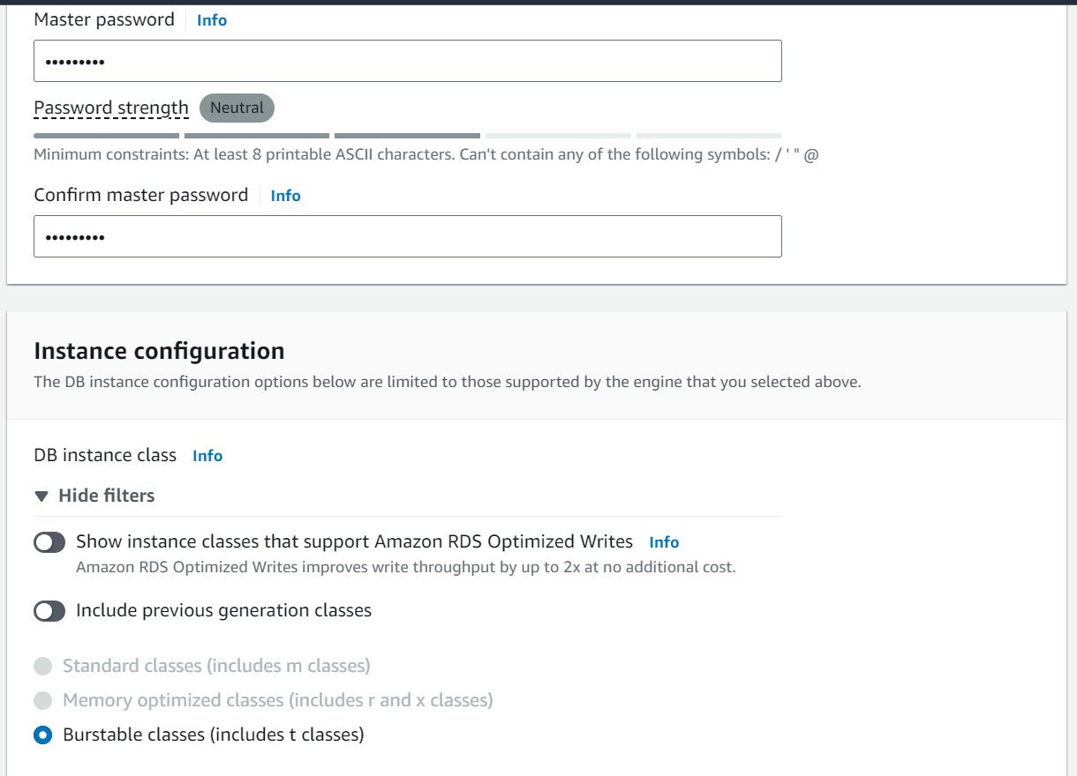

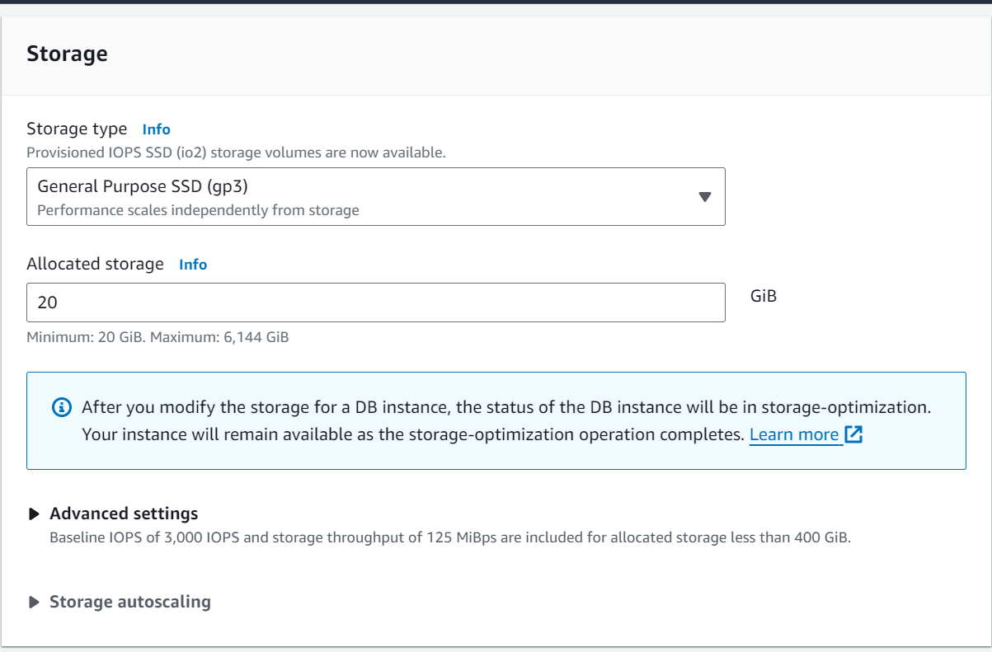

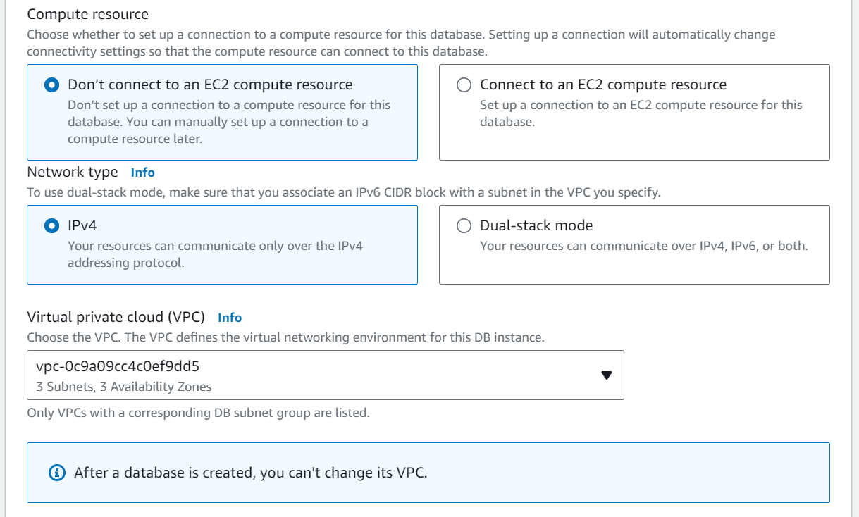

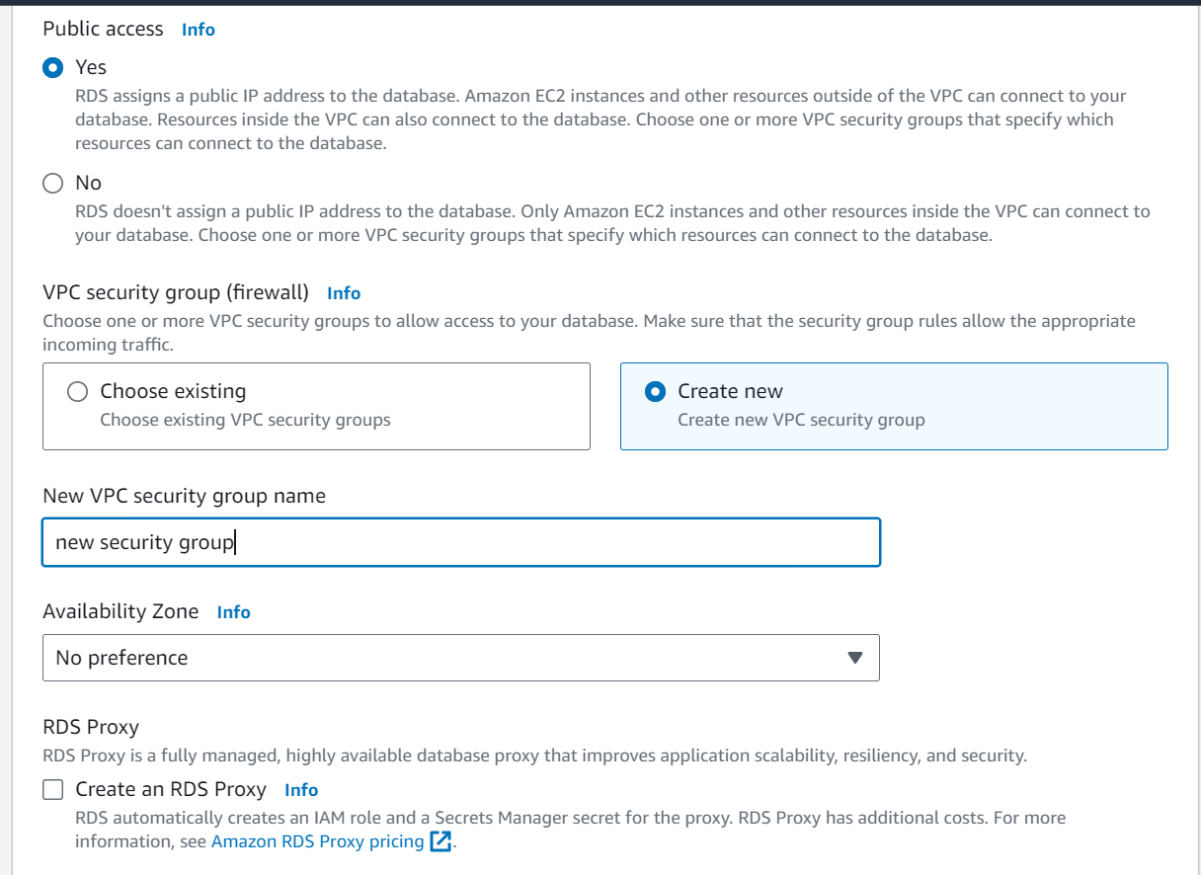

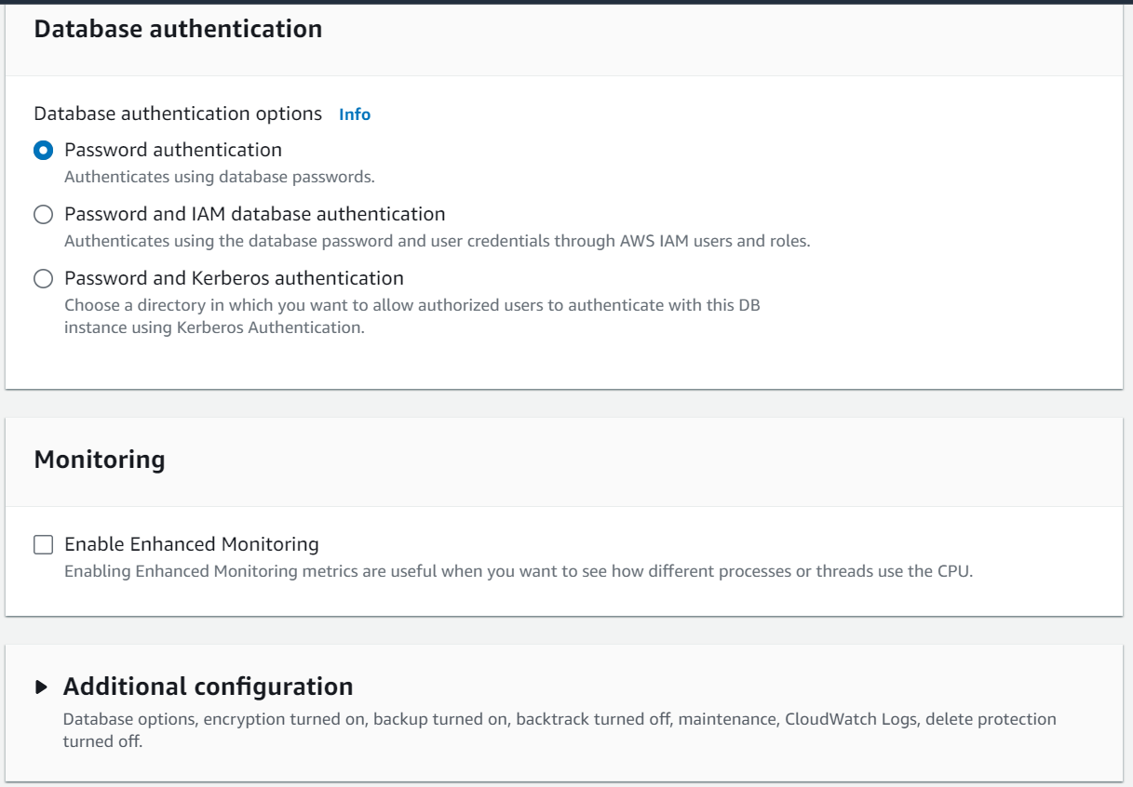

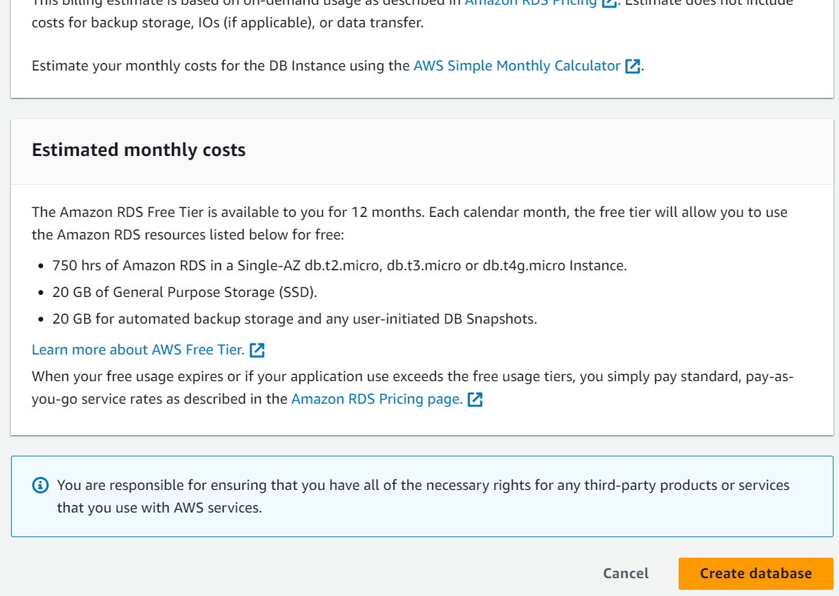

* **Activity 2.2: Configure Database Access**
  + Set up security groups, create database credentials, and configure access policies to ensure secure connectivity to the database.
* **Activity 2.3: Install MySQL Workbench**
  + Download and install MySQL Workbench on your local machine for database management.

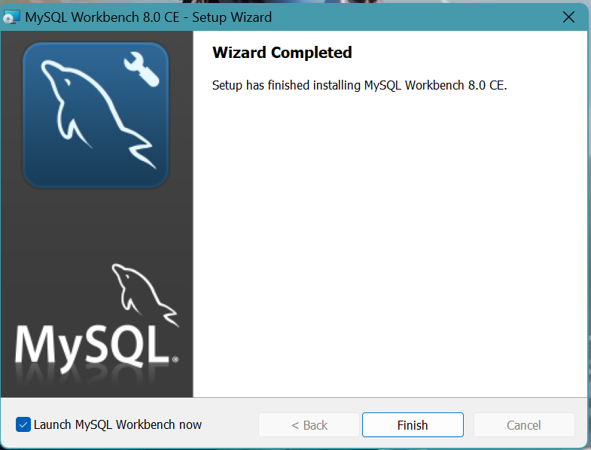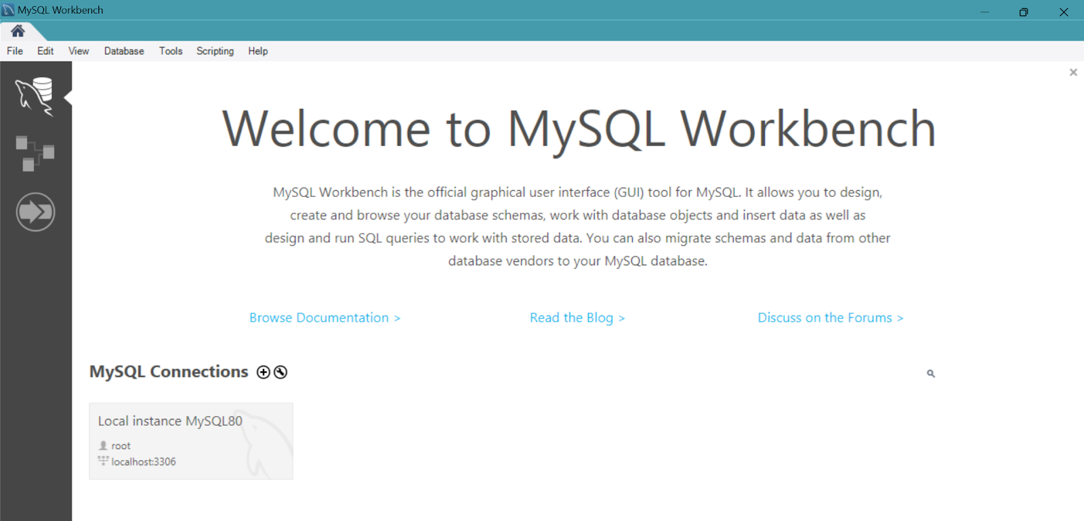

* + Connect to the RDS instance via MySQL Workbench using the endpoint and credentials from AW
  + 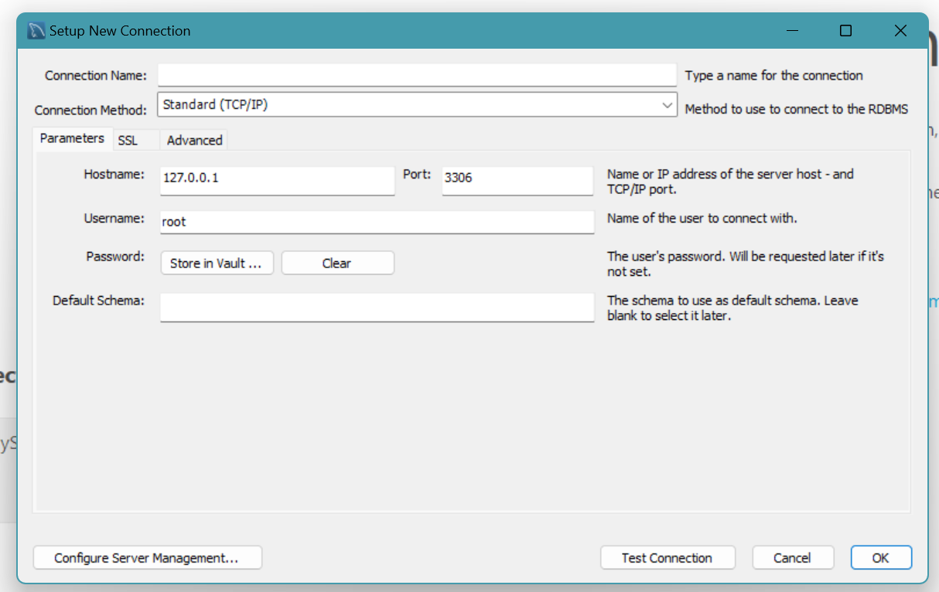
* Give a connection name.
* Copy the endpoint from the RDS database that is created in AWS and paste it in **Hostname.**
* Write the username and enter the password , then click on **Test Connection**.
* Once the connection is successful, you’ll be welcomed with this interface

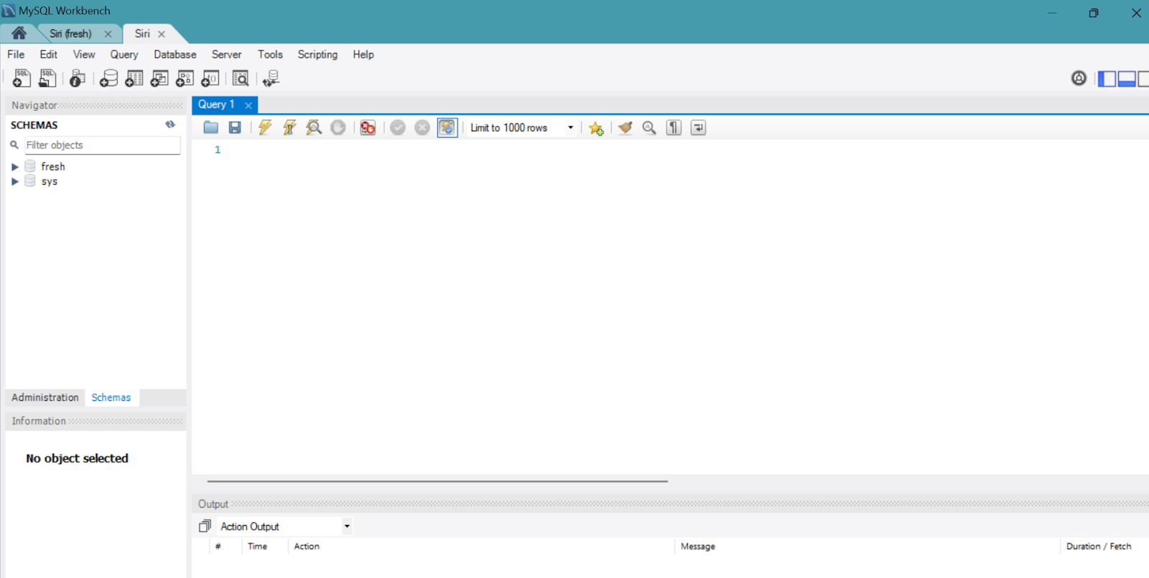

**Activity 2.4:** Create the Database and the tables which are required.

* **Create a basic database schema for an University semester exam registration platform**

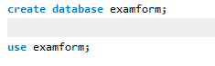

**students_details:**

* Stores student’s information such as name, rollno, batch, department, father’s name, mother’s name, address, email, password.
* Each student has a unique ID (studnets_id), which serves as the Auto increment primary key.

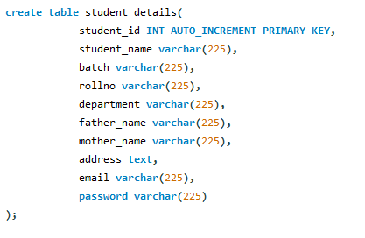

**application:**

* Contains student_id(foreign key from student_details), year, semester, payment

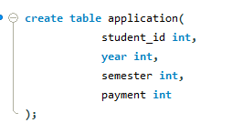

**exam_fee:**

* Contains year, semester and payment.

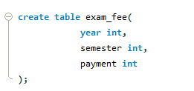

**Application_details:**

* This table has been created by joining student_details and application table.
* Add two more columns such as payment_status(paid/not paid) and application_number(unique for each application)

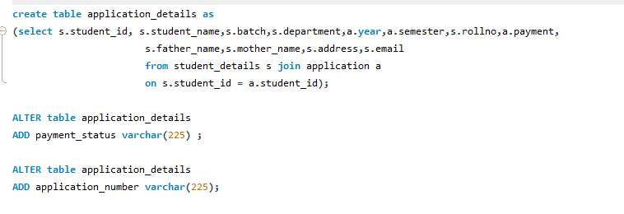

### **Data Operations:**

**1. Data Retrieval**: We retrieved data from each table to view the stored information.

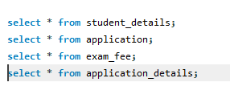

**Milestone 3: Frontend Development and Application Setup**

* **Activity 3.1: Build the Frontend**
  + Develop HTML, CSS, and Python-based Flask application files for ExamEase frontend interface.

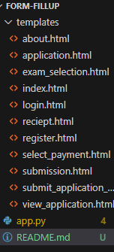

* **Activity 3.2: Integrate Application with RDS**
  + Connect app.py (Flask application) to the MySQL RDS database by configuring database connection settings and verifying connectivity.

**Description of the code :**

1. **Flask App Initialization**: Initializes a Flask application with a secret key for sessions.

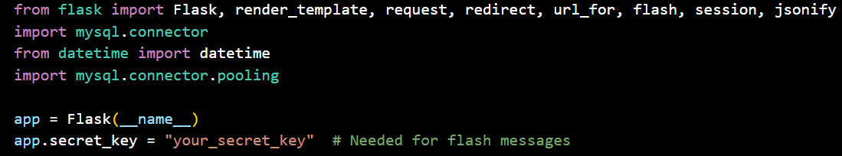

1. **Database Configuration**: Configures MySQL RDS with connection pooling for efficient database access.

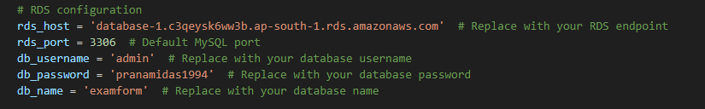

1. **Connection Pool**: Uses MySQL connection pooling to handle multiple database connections.

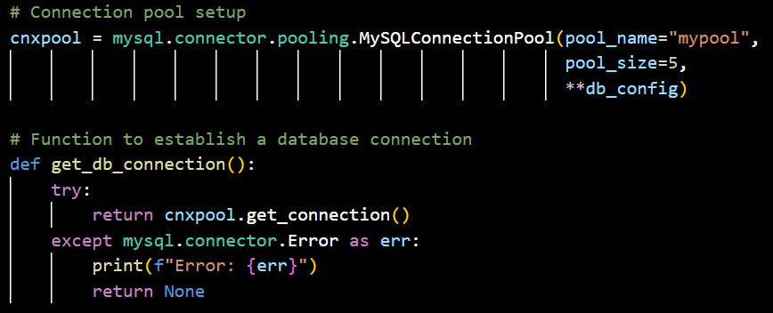

1. **Index Route**: Renders the index page template when the root URL is accessed.

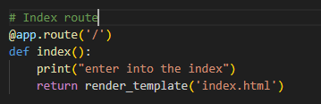

1. **Register Route**:

* **Store student’s data**: It stores user information in the database.
* **Rendering the register page**: After storing the student’s data, it renders the register.html template.

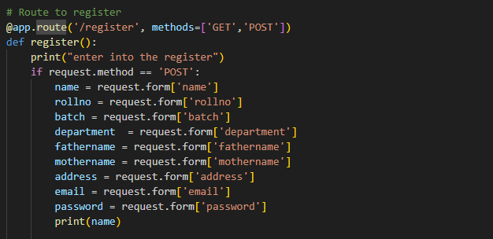

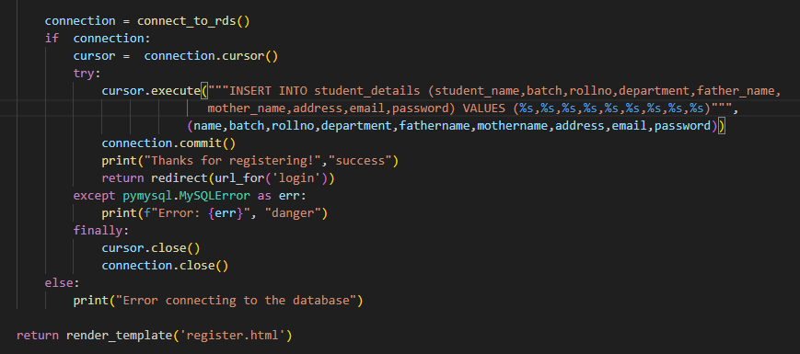

1. **Login Route[GET/POST]**: Login into the application using user email and password

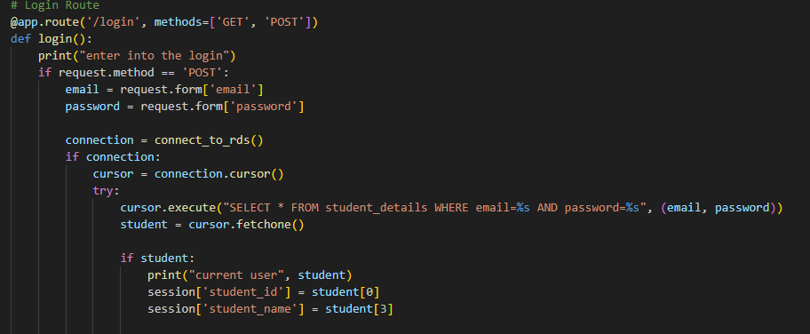

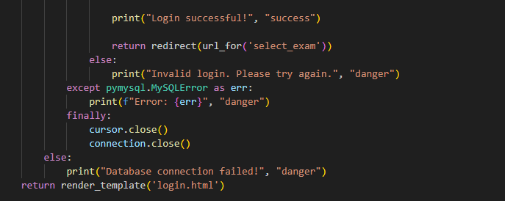

1. **Exam_selection Route(GET/POST):**

* **Display exam data**: It displays year and semester options
* **Insert exam data:** Insert the selected year and semester in the database
* **Rendering the exam_selection page**: After retrieving and storing the selected exam data, it renders the exam_selection.html template.

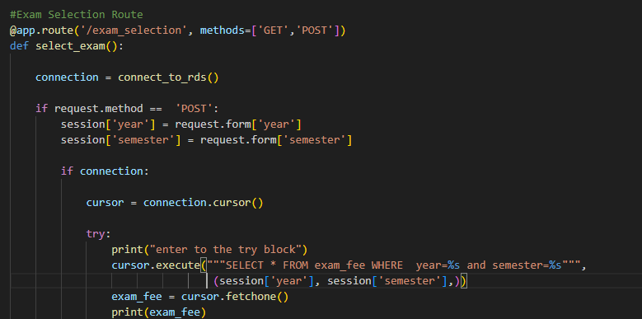

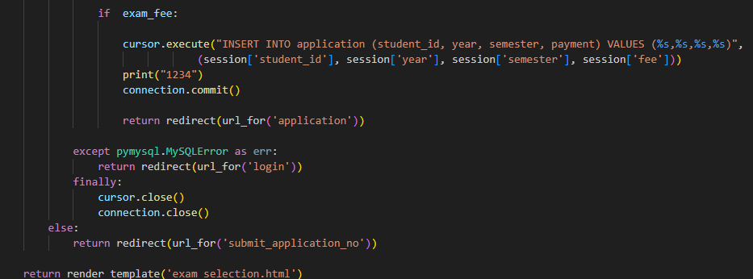

1. **Application Route(GET/POST):**

* **Display the student’s data:** It displays the student's application before payment.
* **Rendering the application page**: It renders the application.html template.

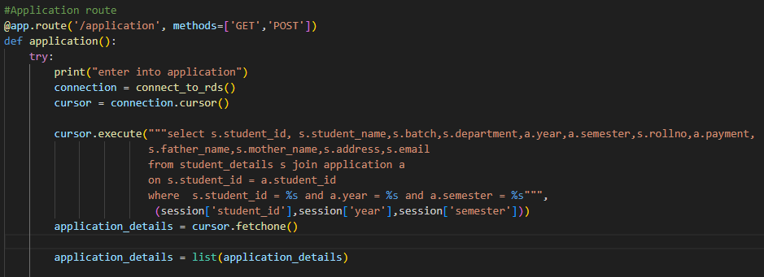

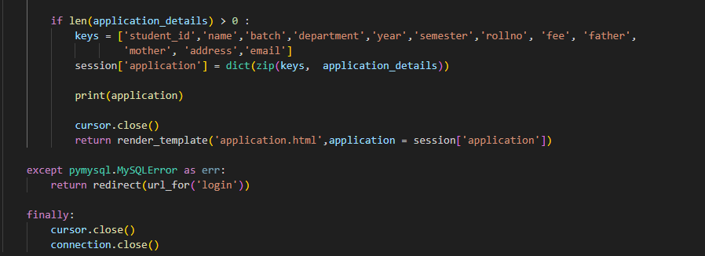

1. **Select_payment Route(GET/POST):**

* **Display booking details:** It displays the options of payment modes and selecting any mode of payment it generates an application number which is unique to every application.
* **Rendering the bookingdetails page**: After displaying the booking data, it renders the bookingdetains.html template.

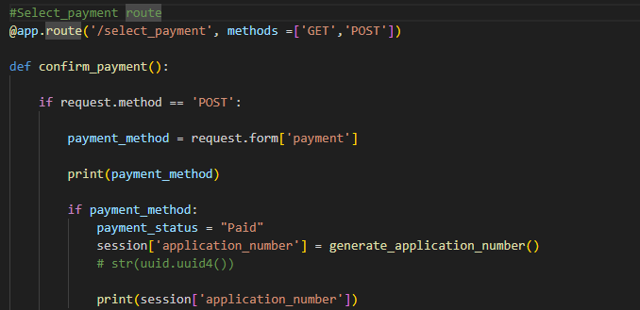

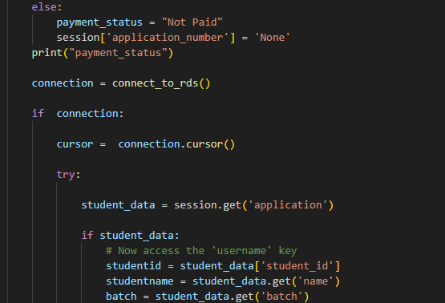

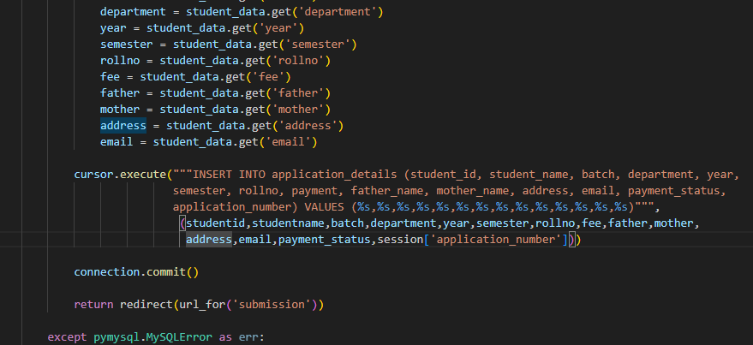

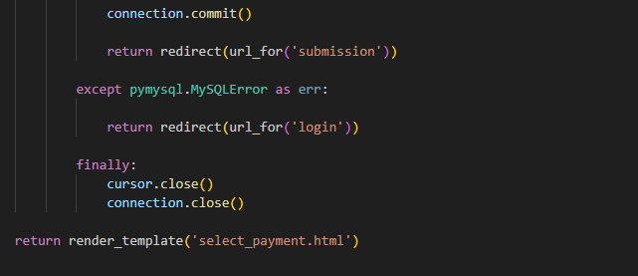

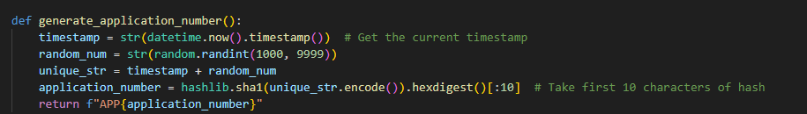

1. **Submission Route:**

* **Display Application number:** It displays application number(unique to every application) after payment and displays a Thank you message.
* **Rendering the submission page**: it renders the submission.html template.

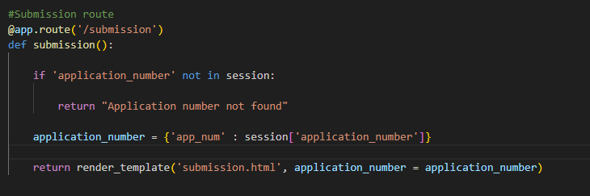

1. **Submit application route(GET/POST):**

* **Insert student’s details:** Insert application number, name and password to display the application.
* **Rendering the submit_application page**: It renders the submit_application.html template.

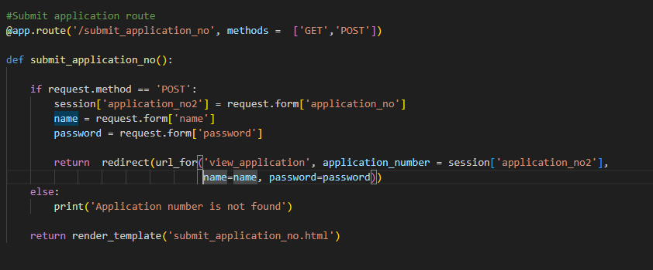

1. **View application Route:**

* **Display application:** It displays the application by entering the application number, name and password in the form.
* **Rendering the view_application page**: It renders the view_application.html template.

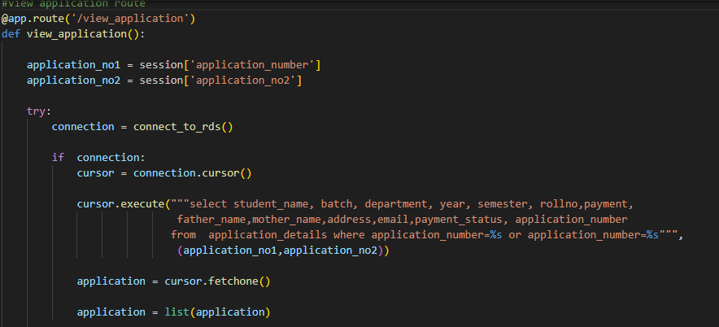

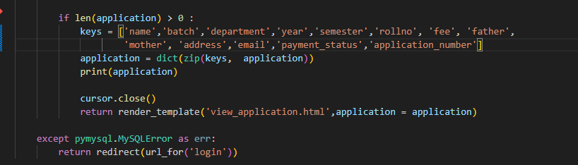

1. **Database Queries**: Uses SQL queries to interact with MySQL RDS for student’s details, application, exam_fee and application_details..
2. **Session Management**: Utilizes Flask session to store students’, applications’ details for seamless navigation within the "ExamEase” application.

**Milestone 4: EC2 Instance Setup**

* **Activity 4.1: Launch EC2 Instance**
  + Choose a Linux-based EC2 instance from the AWS Console to host the ExamEase application.

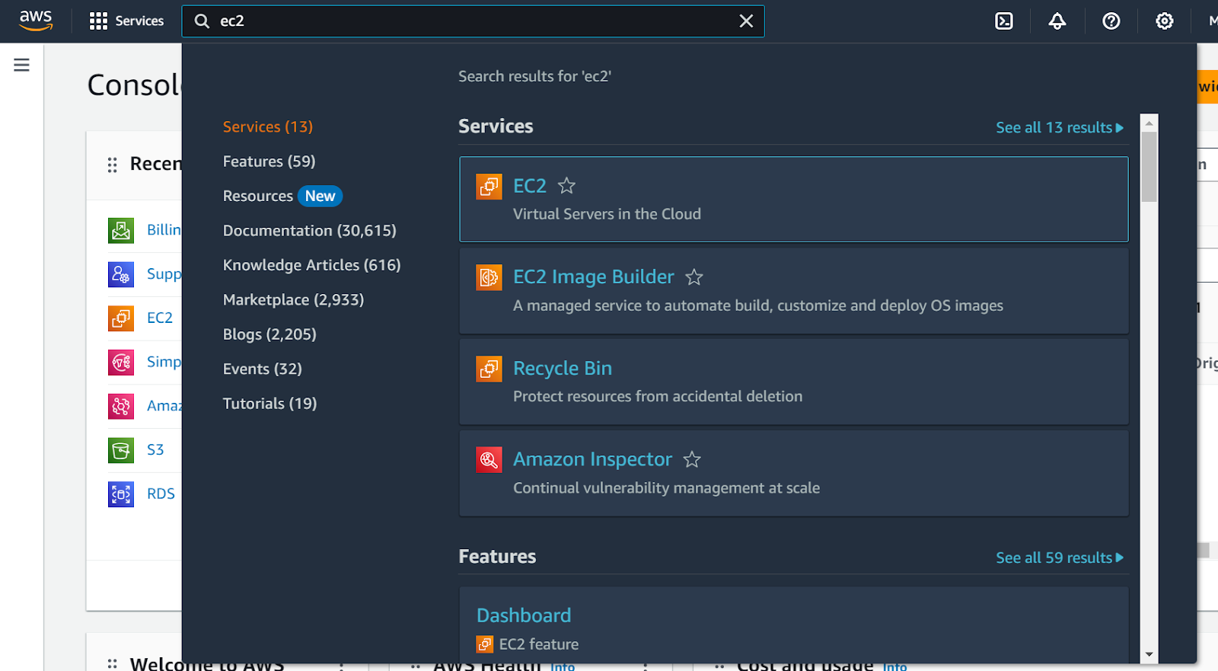

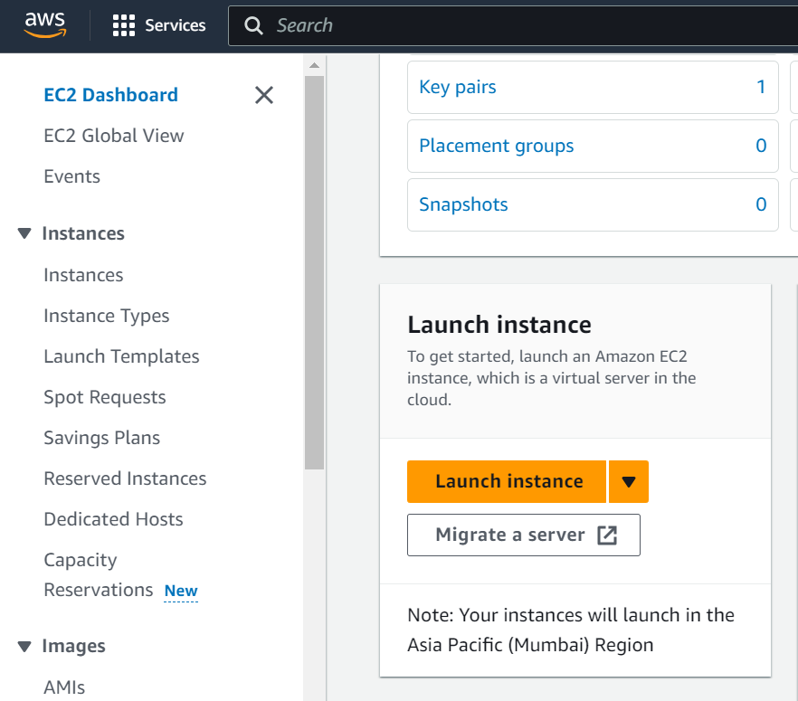

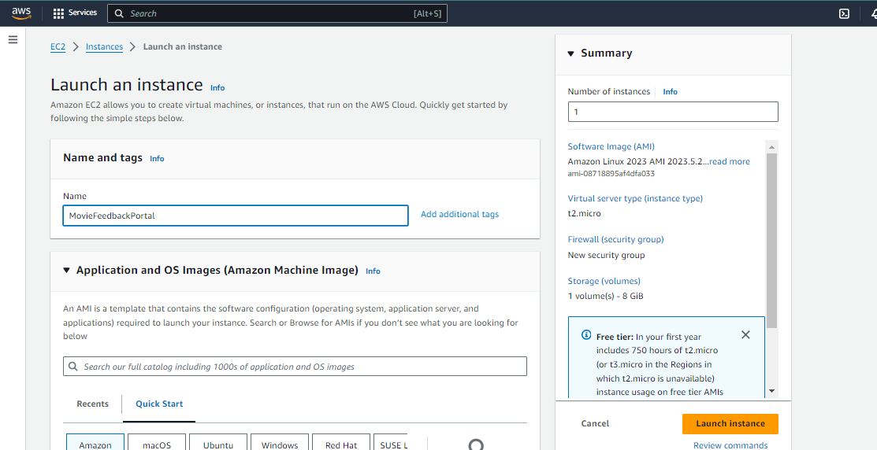

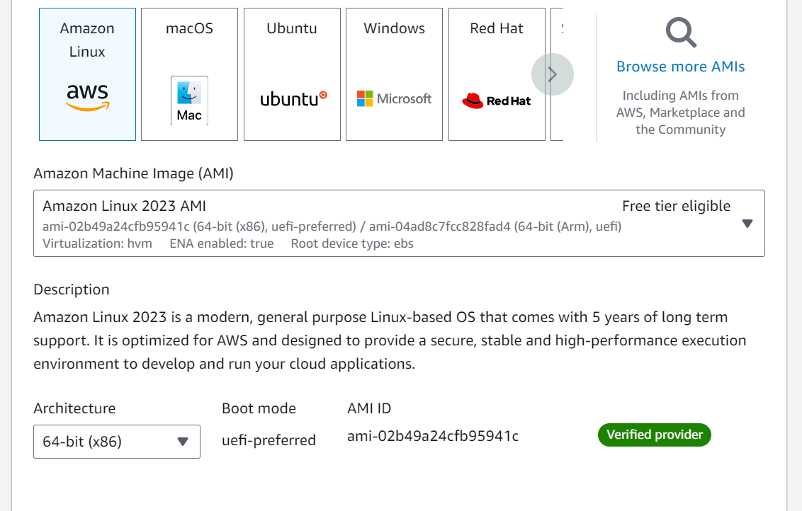

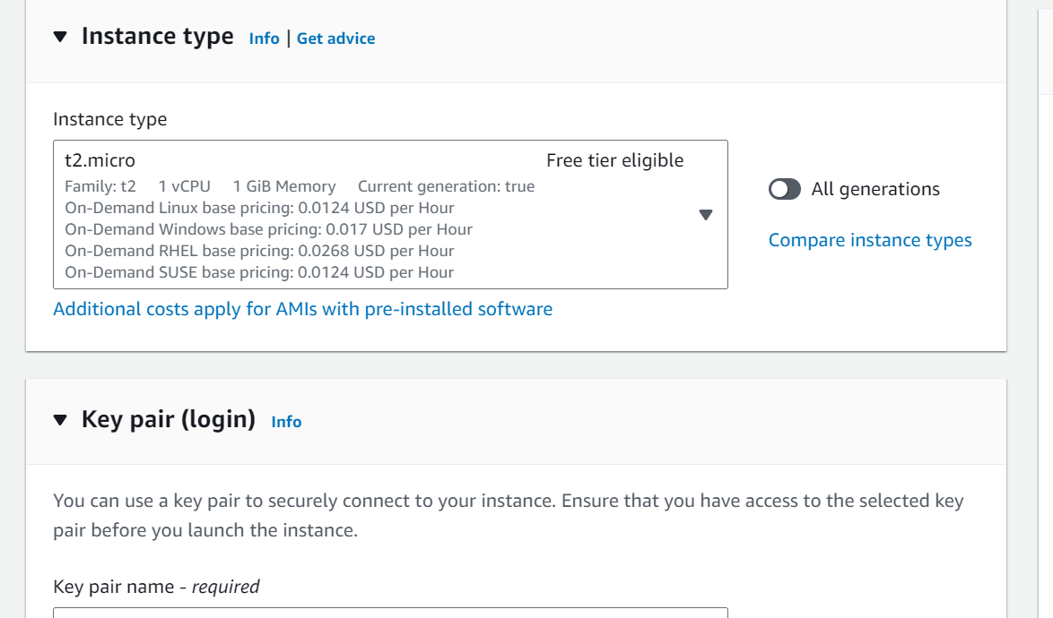

* **Activity 4.2: Configure Network Settings**
  + Set up the security group to allow HTTP, HTTPS, and SSH traffic.

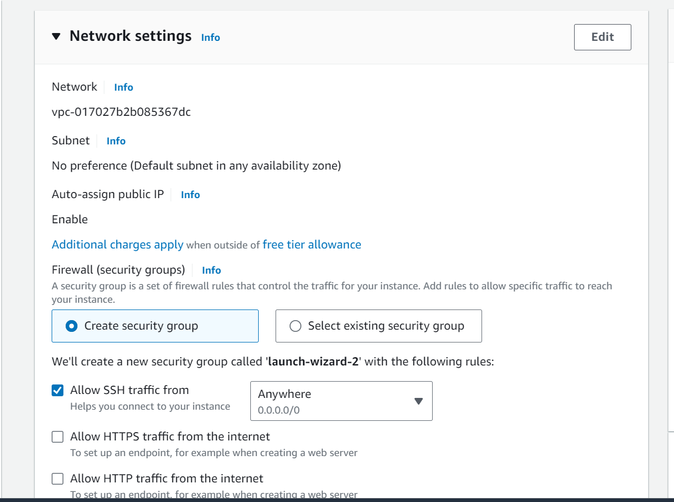

* + Create and download the key pair for SSH access.

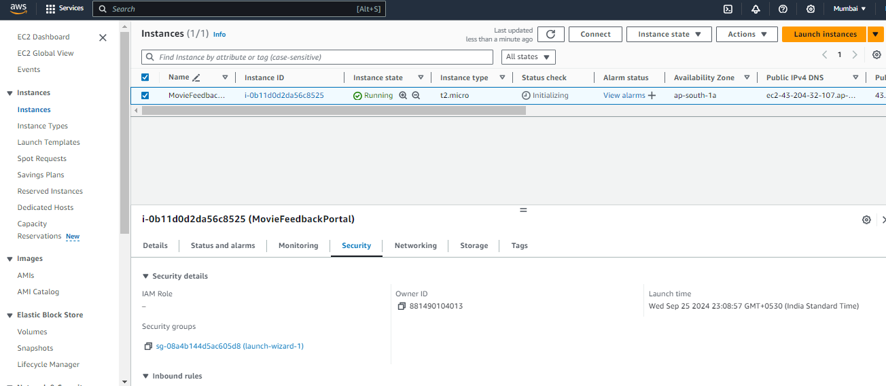

Setting up Inbound and Outbound rules

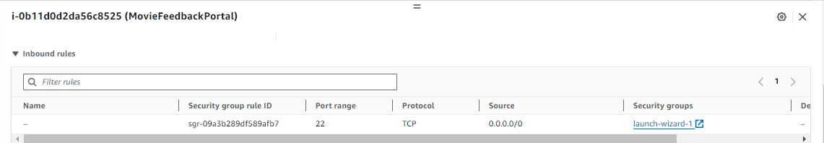

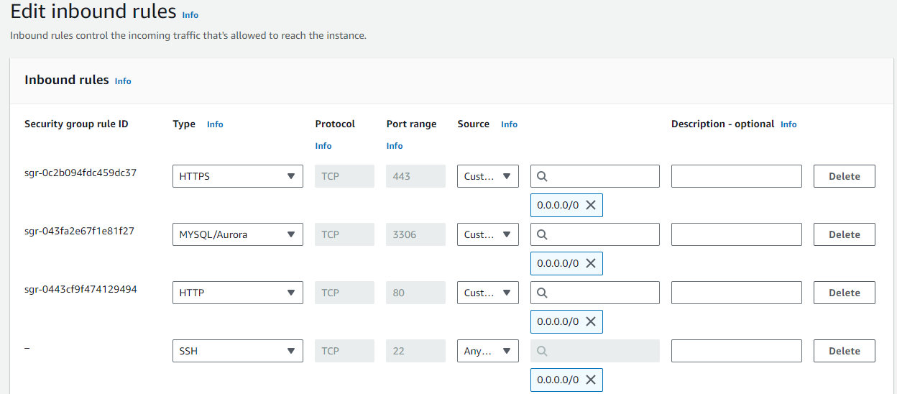

* Add Type : HTTP > Source : Anywhere
* Add Type : HTTPS > Source : Anywhere

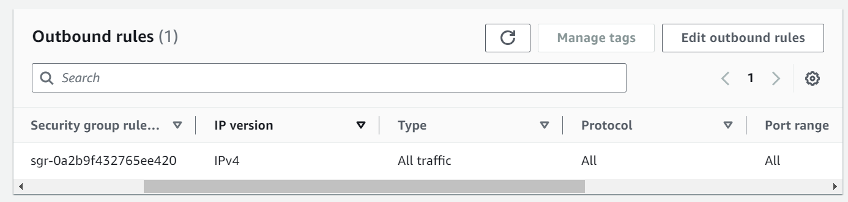

**Milestone 5: Deployment on EC2**

**Activity 5.1: Deploy to EC2**

1. Connect EC2 terminal.
2. Set up any necessary environment variables, including database connection strings.
3. Configure the web server to serve your application.
4. Start your application and ensure it's accessible via the EC2 instance's public IP or domain.

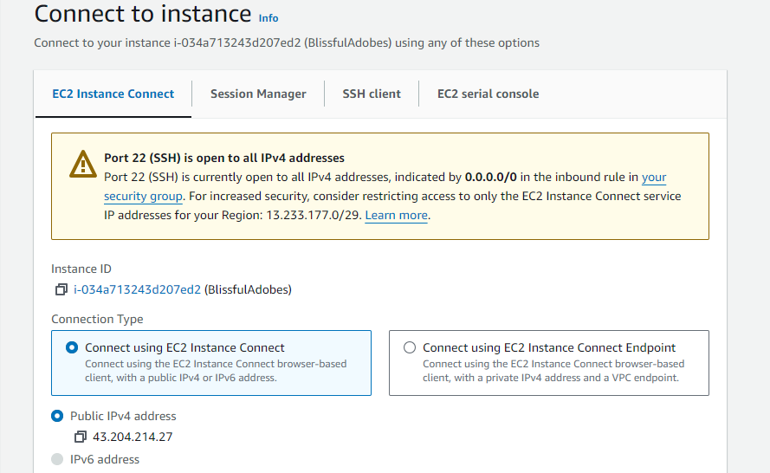

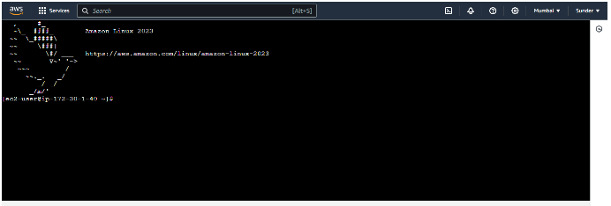

1. Run the below commands on ec2 terminal
2. sudo yum update -y
3. sudo yum install python3 -y
4. sudo pip3 install virtualenv
5. python3 -m venv venv
6. source venv/bin/activate
7. pip install flask
8. git clone <https://github.com/Pranami-1994/semester_exam_form.git>
9. cd your-flask-app
10. python3 app.py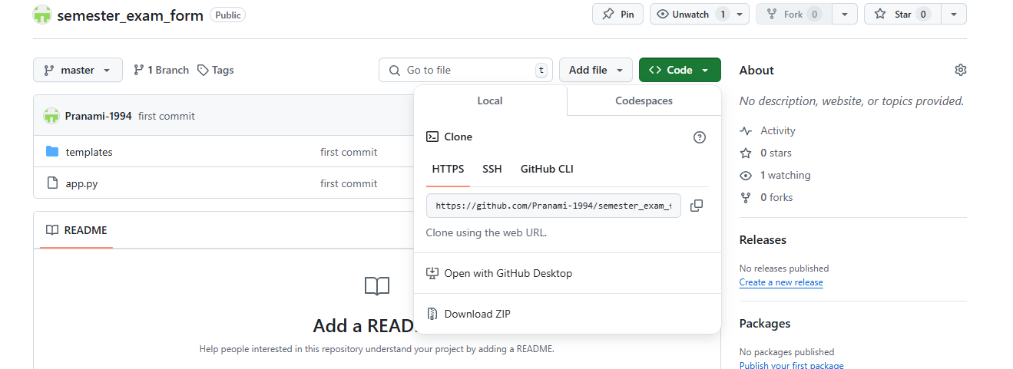

**Milestone 6: Testing and Deployment**

* **Activity 6.1: Functional Testing**
  + Test the CinemaBooker application for functionality, including database interactions and frontend features.
  + Run the Flask app **python3 app.py**
  + It will give you the link

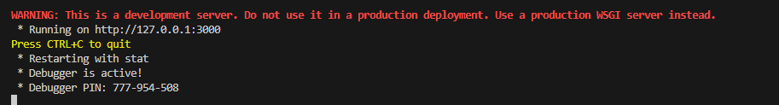

* **Activity 6.2: Deployment**
  + Deploy the application in a production environment, ensuring high availability and performance.

Click on the link above and it will take you to the webpage: <http://127.0.0.1:3000>

**Home:** Proceed to register for your application



**Register page:**

* Register for your semester exam.
* Put Name, RollNo, Father’s name, Mother’s name, Batch, Department, Address, Email.
* Set a password for your account.

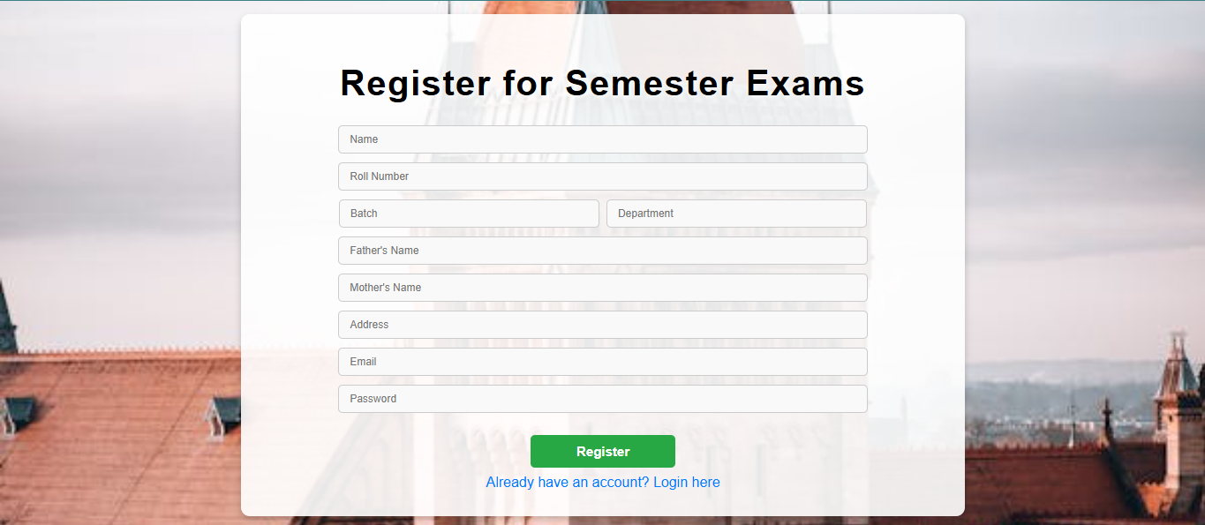

**Login page:**

* Put your email and password for login

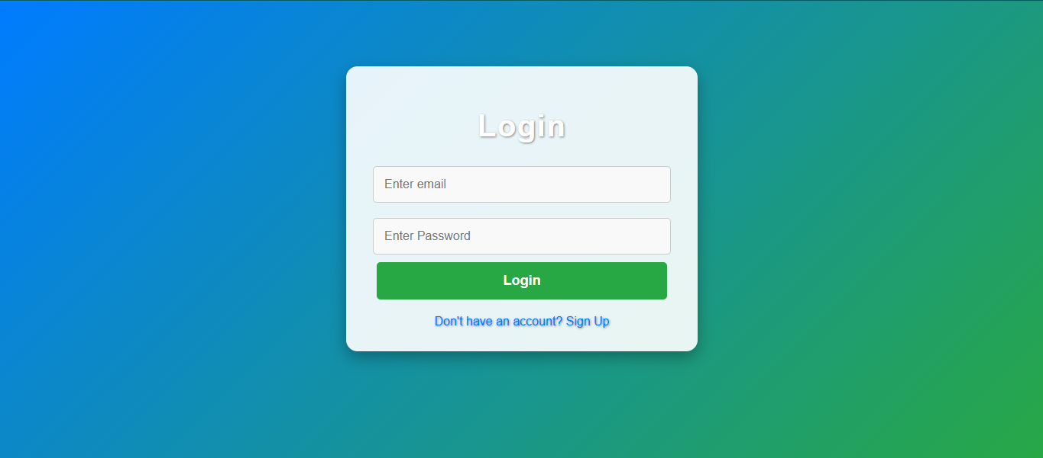

**exam_select Page:**

* Select Year and semester if no application has been submitted.
* View application if application has been submitted already.

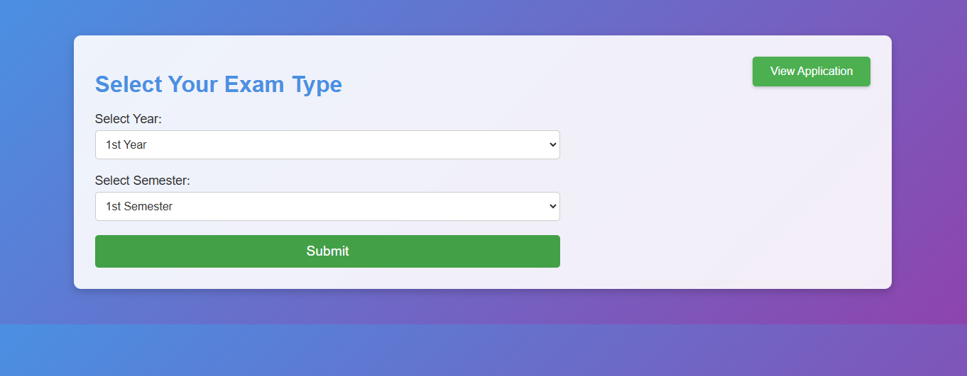

**Application page:**

* Review your application before payment.

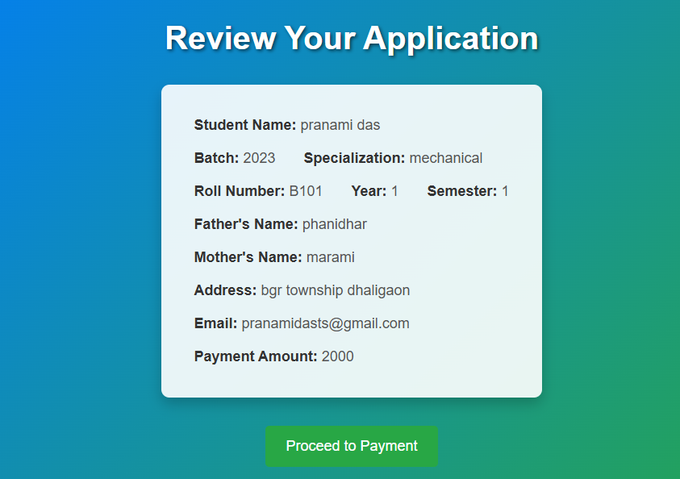

**select_payment page:**

* Select payment mode

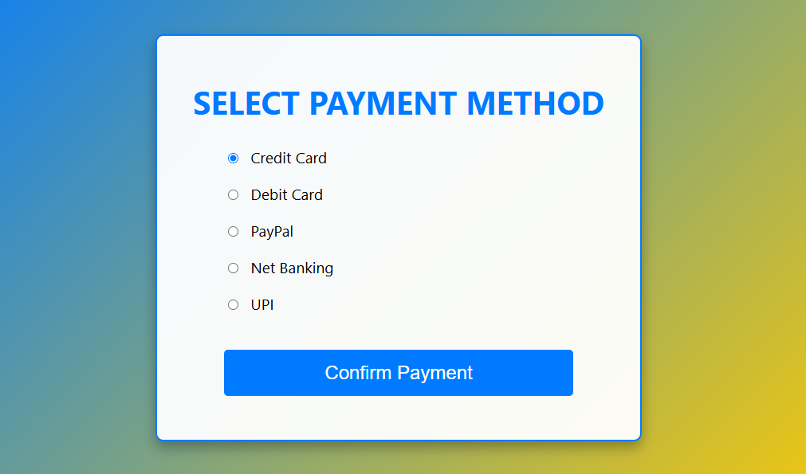

**submission page:**

* This page will show you your submission and generate one application number.
* Keep the application number for your future reference.

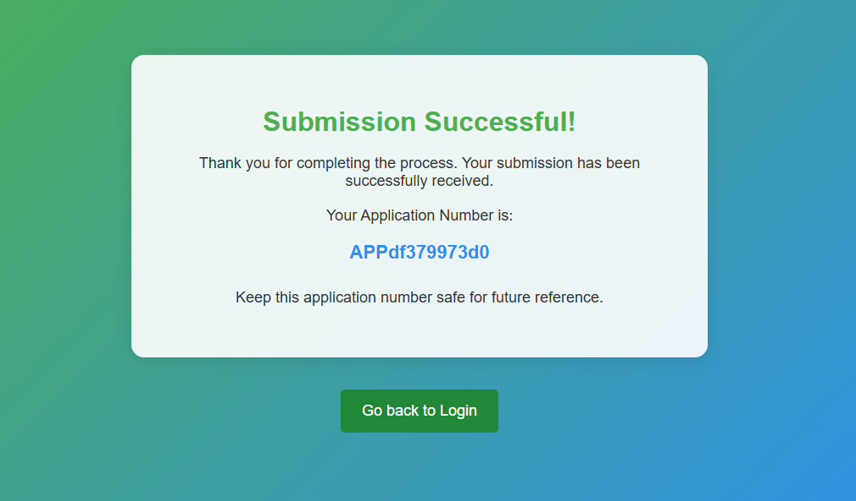

**submit_application_no page:**

* From the exam_select page you can go to the submit_application page by selecting the “View application” option and view your application.
* To view your application, put your application number, name and password.

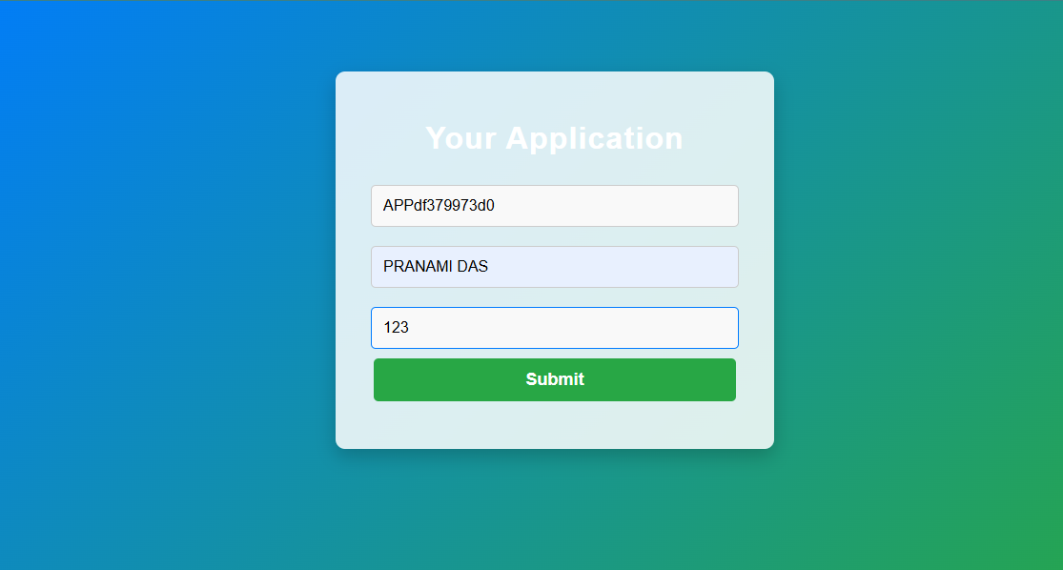

**view_application page:**

* This is your Application for your exam.
* It will show all your details which are given by you at the time of your registration.

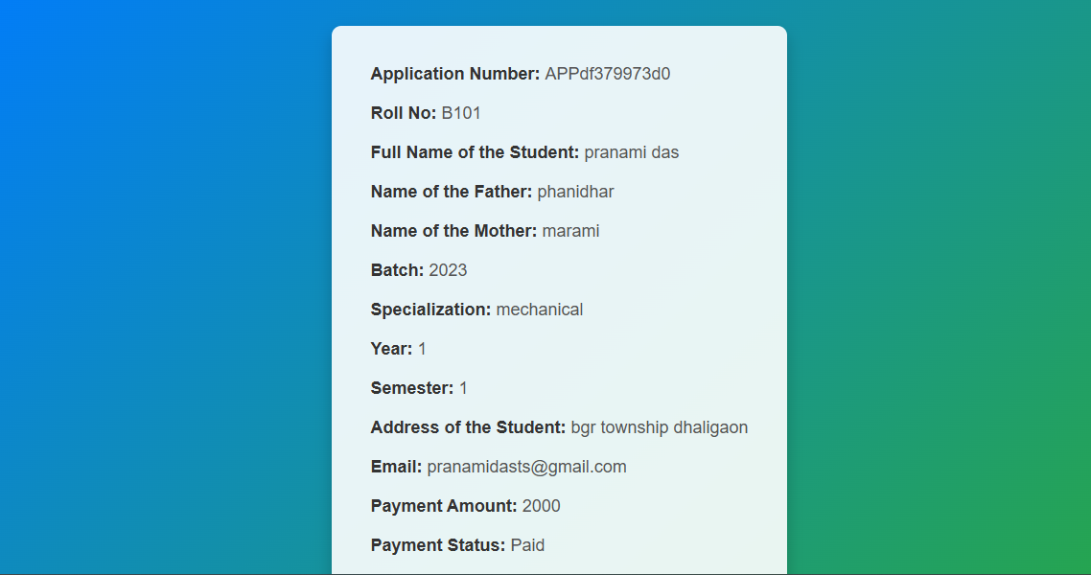

* **Activity 6.3: Check the updations in the mysql database.**

**MySql Database updations :**

1. **Student_detetails table :   
   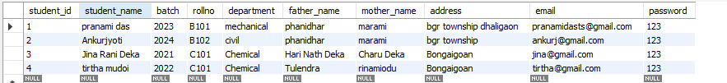**
2. **Application table :**  
   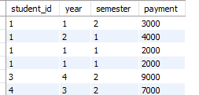
3. **exam_fee table:**

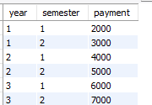**.**

1. **Application_details table**

**Milestone 7: Monitoring and Optimization**

* **Activity 7.1: Performance Monitoring**
  + Set up AWS CloudWatch for monitoring EC2 and RDS performance metrics.
  + Implement alerts and notifications for critical performance thresholds.
* **Activity 7.2: Optimization**
  + Optimize the server and database configurations based on monitoring results, including adjusting instance types and query optimization.

**Conclusion:**

The ExamEase project showcases a well-structured and accessible university semester exam registration portal powered by AWS. Using Flask for backend development and integrated with a secure, scalable database, the platform seamlessly manages form submissions, payment processing, and student records. AWS services support ExamEase’s efficient deployment and elasticity, allowing it to handle high submission volumes during registration periods without compromising performance. Every component, from the clear and straightforward user interface to robust data encryption, is designed to enhance user convenience and ensure data security. This project exemplifies how cloud technologies can transform administrative processes in higher education, enabling institutions to meet evolving needs while delivering a smooth, reliable experience for students and staff alike.